Assessment in Geography

Informing Pupils of Targets:
- On the inside cover of pupils Humanities books, a target sheet displaying subject specific objectives for both History and Geography is glued in
- In each lesson, pupils are guided towards the relevant targets they will be working on
- This ensures that pupils are accurately informed about the skills and knowledge they will be developing within every lesson and over time as part of a wider unit of work
- Pupils self and peer-assess (where appropriate) against the relevant targets at the end of each lesson

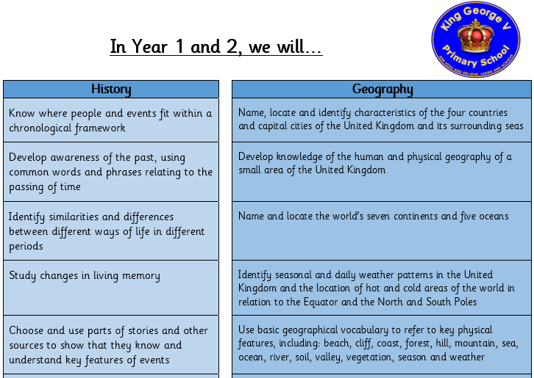

Ongoing Assessment:
- Class Teachers and HLTAs (where appropriate) use a range of Assessment for Learning strategies in order to formatively assess pupils’ achievements and progress within lessons.

Formal Assessment:
- Pupils’ achievements and progress is assessed formally by Class Teachers at the end of each unit of work (once per half term)

- At the end of each unit of work, pupils complete an end of unit assessment based on the sticky knowledge taught over the course of the unit. This quiz tests pupils’ retention of key information

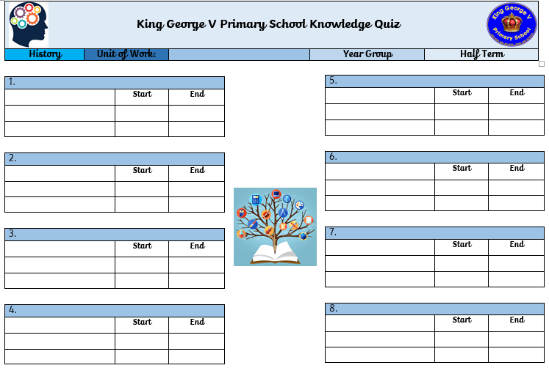

- Pupils’ results from the end of unit assessment support the Class Teacher in accurately assessing pupils knowledge and understanding. The banding used in end of unit knowledge quizzes is:

0%-25% | Working Towards ARE
26%-45% | Emerging ARE
46%-65% | Working at ARE
66%-85% | Working Towards Greater Depth
86%-100% | Working at Greater Depth

- In the final lesson in each unit of work, pupils also complete an application task which forms the second aspect of formative assessment in Geography

- Pupils are given a task, which could include a key question to respond to. Class Teachers use the Rising Stars Progression Framework to assess pupils’ responses in order to assess whether they are Working Towards ARE, Working At ARE or Working at Greater Depth

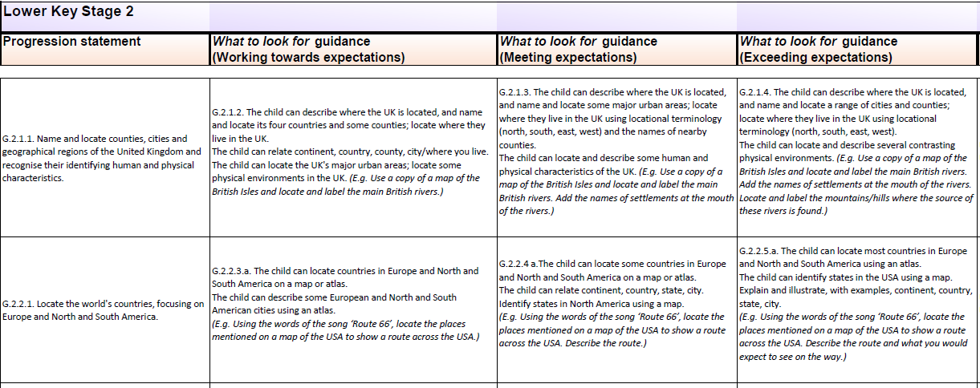

- Once pupils have completed an end of unit knowledge quiz and an end of unit application task, Class Teachers use the assessment information gathered to arrive at a Teacher Assessment Judgement which is recorded on the tracking grid below:

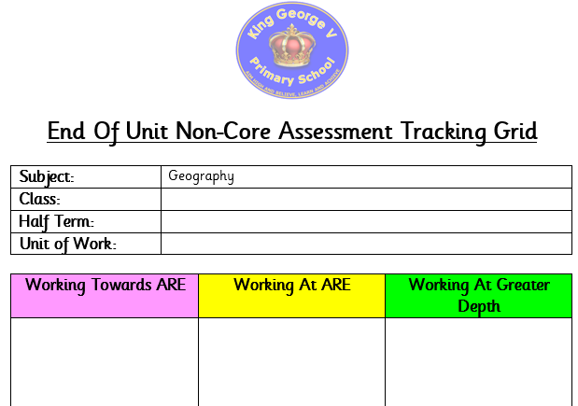

Reporting and Tracking:
- Class Teachers share completed assessment records with the Subject Leader and Curriculum Lead (DHT) at the end of each unit
- The data submitted is analysed by Leaders in order to identify trends and areas for further development

Moderation:
- Non-Core assessment data is reviewed termly by Subject Leads, the Curriculum Lead and SLT and is subject to internal moderation.
- Class teachers discuss the attainment and progress of pupils in all non-core subjects at termly Pupil Progress meetings with members of SLT.

